1**) Explain the types of gray level transformation used for image enhancement. 10**

# Gray Level Transformation

All Image Processing Techniques focused on gray level transformation as it operates directly on pixels. The gray level image involves 256 levels of gray and in a histogram, horizontal axis spans from 0 to 255, and the vertical axis depends on the number of pixels in the image.

**The simplest formula for image enhancement technique is:**

1. s = T * r

Where T is transformation, r is the value of pixels, s is pixel value before and after processing.

Let,

1. r = f(x,y)
2. s = g(x,y)

'r' and 's' are used to denote gray levels of f and g at(x,y)

There are three types of transformation:

1. Linear
2. Logarithmic
3. Power - law

The overall graph is shown below:

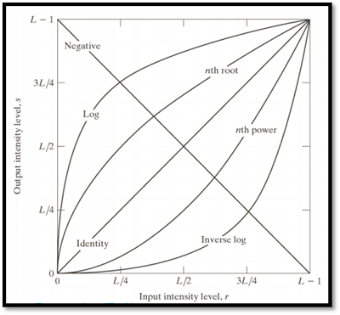

## Linear Transformation

The linear transformation includes identity transformation and negative transformation.

**In identity transformation**, each value of the image is directly mapped to each other values of the output image.

**Negative transformation** is the opposite of identity transformation. Here, each value of the input image is subtracted from L-1 and then it is mapped onto the output image

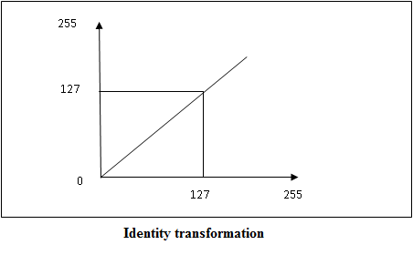  
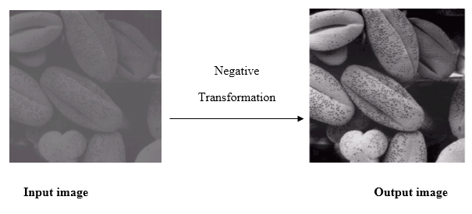

## Logarithmic transformations

Logarithmic transformation is divided into two types:

1. Log transformation
2. Inverse log transformation

The formula for Logarithmic transformation

1. s = c log(r + 1)

Here, s and r are the pixel values for input and output image. And c is constant. In the formula, we can see that 1 is added to each pixel value this is because if pixel intensity is zero in the image then log(0) is infinity so, to have minimum value one is added.

When log transformation is done dark pixels are expanded as compared to higher pixel values. In log transformation higher pixels are compresses.

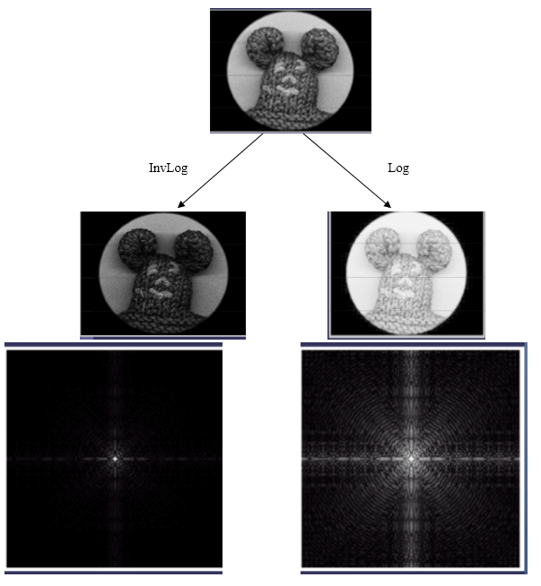

In the above image (a) Fourier Spectrum and (b) result of applying Log Transformation.

## Power - Law transformations

Power Law Transformation is of two types of transformation nth power transformation and nth root transformation.

**Formula:**

1. s = cr ^ γ

Here, γ is gamma, by which this transformation is known as gamma transformation.

All display devices have their own gamma correction. That is why images are displayed at different intensity.

These transformations are used for enhancing images.

**For example:**

Gamma of CRT is between 1.8 to 2.5

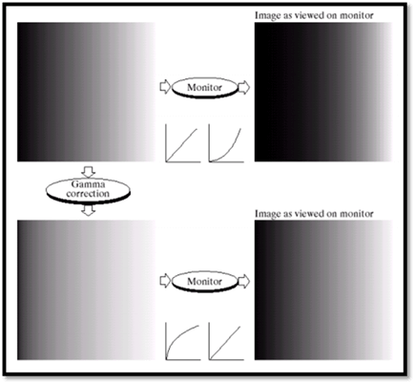

Image Enhancement

The main objective of Image Enhancement is to process the given image into a more suitable form for a specific application. It makes an image more noticeable by enhancing the features such as edges, boundaries, or contrast. While enhancement, data does not increase, but the dynamic range is increased of the chosen features by which it can be detected easily.

In image enhancement, the difficulty arises to quantify the criterion for enhancement for which enhancement techniques are required to obtain satisfying results.

**There are two types of Image enhancement methods:**

1. Spatial domain technique
2. Frequency domain technique

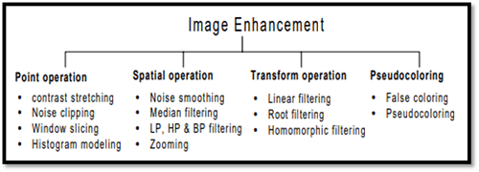

Spatial domain enhancement methods

Spatial domain techniques are performed on the image plane, and they directly manipulate the pixel of the image.

Operations are formulated as:

1. g(x,y) = T[f(x, y)]

Where g is the output image, f is the input image, and T is operation

Spatial domain techniques are further divided into 2 categories:

* Point operations (linear operation)
* Spatial operations (non-linear operation)

Frequency domain enhancement methods

Frequency domains enhance an image by following complex linear operators.

1. G(w1, w2) = F(w1, w2) H(w1, w2)

Image enhancement can also be done through Gray Level Transformation.

**3). Briefly discuss the different types of processing in an Histogram**

Histogram Processing Techniques

Histogram Sliding

In Histogram sliding, the complete histogram is shifted towards rightwards or leftwards. When a histogram is shifted towards the right or left, clear changes are seen in the brightness of the image. The brightness of the image is defined by the intensity of light which is emitted by a particular light source.

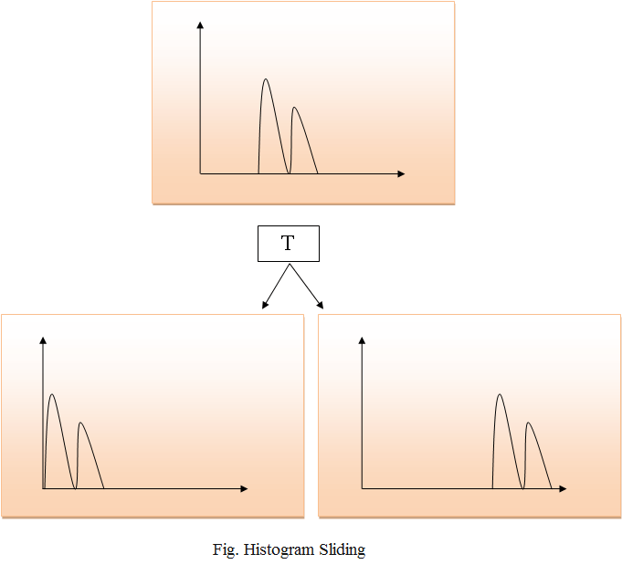

Histogram Stretching

In histogram stretching, contrast of an image is increased. The contrast of an image is defined between the maximum and minimum value of pixel intensity.

x

If we want to increase the contrast of an image, histogram of that image will be fully stretched and covered the dynamic range of the histogram.

From histogram of an image, we can check that the image has low or high contrast.

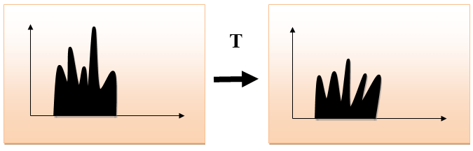

Histogram Equalization

Histogram equalization is used for equalizing all the pixel values of an image. Transformation is done in such a way that uniform flattened histogram is produced.

Histogram equalization increases the dynamic range of pixel values and makes an equal count of pixels at each level which produces a flat histogram with high contrast image.

While stretching histogram, the shape of histogram remains the same whereas in Histogram equalization, the shape of histogram changes and it generates only one image.

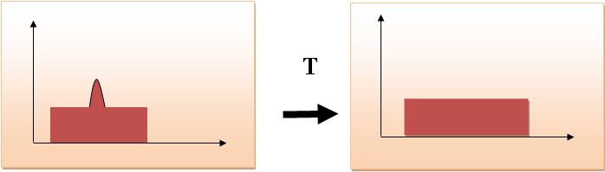

**4. Discuss the concept of Correlation and Convolution in linear spatial filtering**

**with an example.10**

# Correlation vs Convolution Filtering

Filtering an image is replacing each pixel with a linear combination of its neighbors.

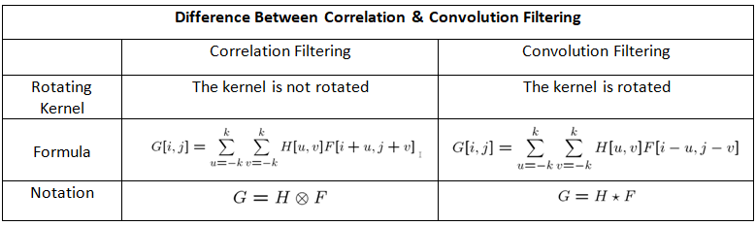

# ****Correlation Filtering****

The basic idea in correlation filtering:

1. Slide the center of the correlation kernel on the image

2. Multiply each weight in the correlation kernel by the pixel in the image

3. Sum these products

To give an example, let’s say we have 2 different matrices. One of them represents our image (F) and the other represents the kernel (H).

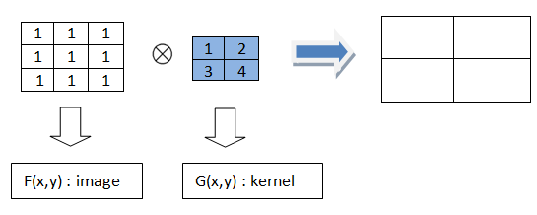

To find the output result, we start to follow our steps. We put the kernel on the image and after multiplying each weight in the kernel by the corresponding pixels, we sum the products. Slide the kernel and repeat the same steps.

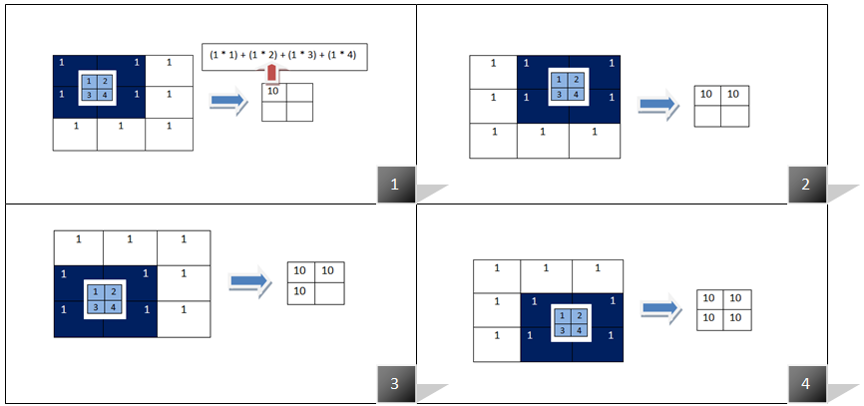

Correlation Filtering

**Some Linear Filters:**

Averaging Filter (Blur Filter): There are several methods to blur an image and one of them is averaging filter. To apply this filter we use correlation.

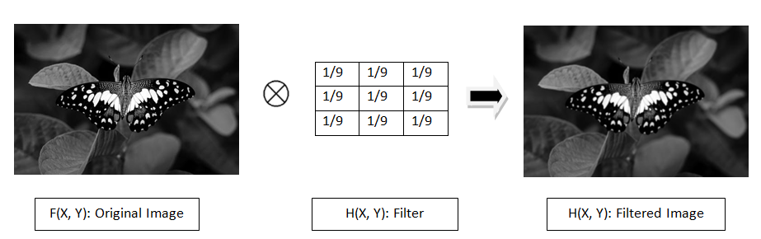

Applying averaging Filter

In the above example, we see a correlation filtering application. When we apply a 3x3 averaging filter (blur filter) to the original image, the image is blurred as we see in the output. The python code below:

import cv2  
import matplotlib.pyplot as plt  
import numpy as np# read image  
src = cv2.imread('btf.jpeg', 0)# prepare averaging filter  
kernel = np.ones((3, 3), dtype=np.float32)  
kernel /= 9# apply kernel to the original image  
dst = cv2.filter2D(src, -1, kernel)# concatenate images horizontally  
result = np.concatenate((src, dst), axis=1)  
cv2.imwrite('output.png', result)

When you run the above code, you come up with:

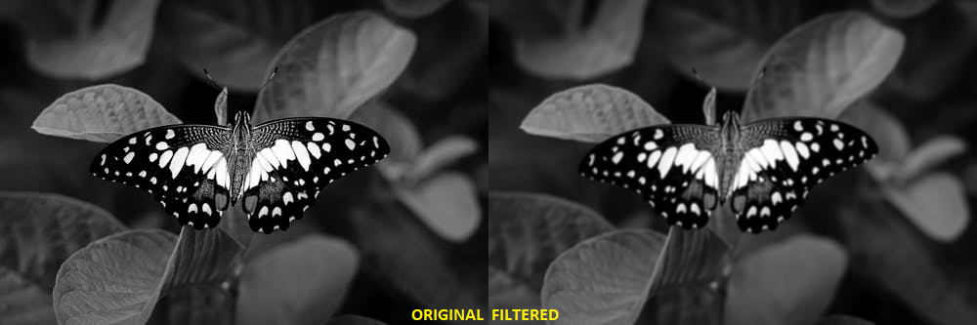

Comparison of the original and blurred image (using 3x3 kernel)

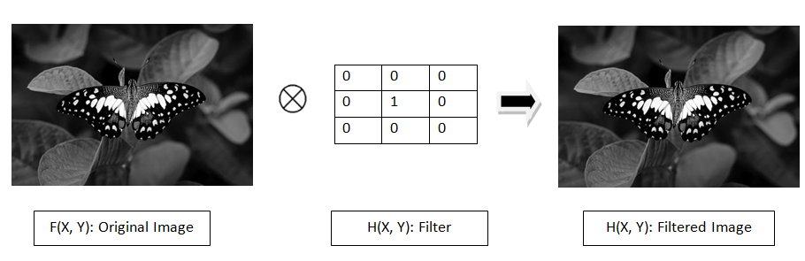

Applying another linear filter

When we apply the above filter to the original image, we see that nothing changes. The filtered image is the same as the original image.

import cv2  
import matplotlib.pyplot as plt  
import numpy as np# read image  
src = cv2.imread('src.png', 0)# prepare the filter  
kernel = [[0,0,0], [0,1,0], [0,0,0]]# apply kernel to the original image  
dst = cv2.filter2D(src, -1, np.array(kernel))# concatenate images horizontally  
result = np.concatenate((src, dst), axis=1)  
cv2.imwrite('result.png', result)

The code is similar to the code of averaging filter. We just specify the kernel manually.

*To see the effects of the filters, you just need to change the kernel value.*

# ****Convolution Filtering****

The convolution filtering is also a linear filtering and it is more common then correlation filtering. There is a small difference between correlation and convolution :

1. Flip the filter in both dimensions (bottom to top, right to left)

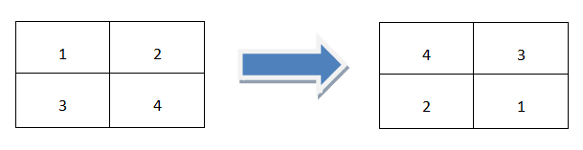

Flip the filter in both dimensions

2. Apply correlation filtering

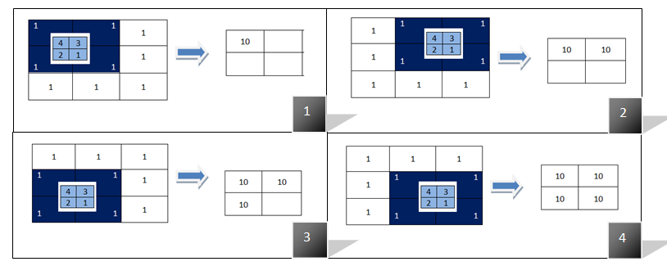

The second step which applying correlation filtering after flipping the kernel

But the code part is a bit different than the correlation filtering. Because there is nothing in opencv to make the convolution filtering directly. To make convolution filtering, there are 2 different way:

1. Flip the kernel in both dimensions in the code and then call filter2D function .
2. Use scipy library instead of opencv to make convolution filtering.

To compare the effects of the filters, let’s apply a random filter on the original image using correlation and convolution filtering.

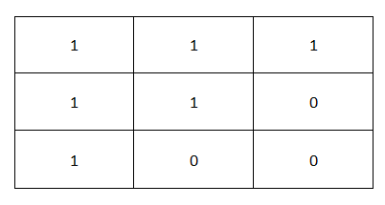

Randomly specified 3x3 filter

***Reminder! :****In correlation filtering, we will use the above filter directly but in convolution filtering, the above kernel will be flipped in both dimensions.*

import cv2  
import matplotlib.pyplot as plt  
import numpy as np  
from scipy import ndimage# read image  
src = cv2.imread('eye.jpg',0)# prepare the filter  
kernel = np.array([[1,1,1],[1,1,0],[1,0,0]])# apply kernel to the original image using convolution filtering  
dst_conv = ndimage.convolve(src, kernel, mode='constant', cval=1.0)  
# apply kernel to the original image using correlation filtering  
dst_corr = cv2.filter2D(src, -1, kernel)# concatenate images horizontally  
result = np.concatenate((src, dst_corr, dst_conv), axis=1)  
cv2.imwrite('result.png', result)

In the above code, we apply the kernel on the same image using both convolution and correlation filtering. Then after we concatenate all results, we save the image. The output of the above code:

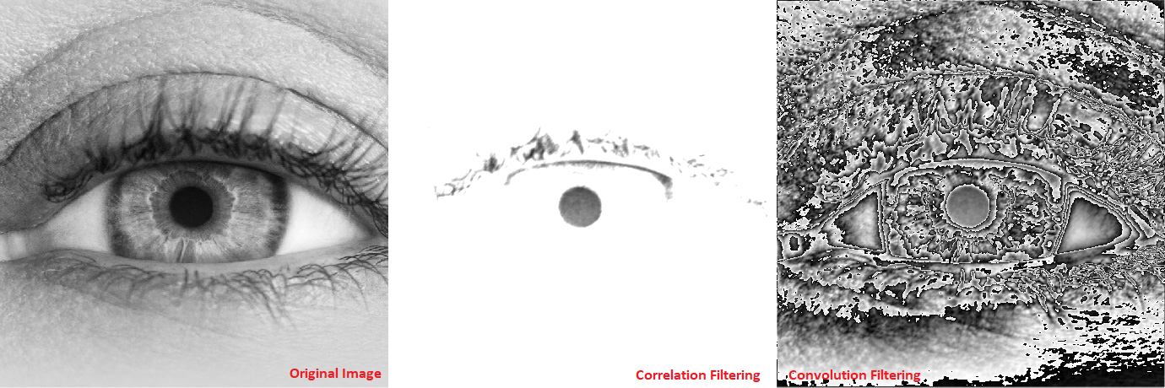

Comparison of the correlation and convolution filtering

5. Discuss the image smoothing filter with its model in the spatial domain. Also

explain its significance in digital image processing.10

# Spatial Filtering and its Types

**Spatial Filtering** technique is used directly on pixels of an image. Mask is usually considered to be added in size so that it has specific center pixel. This mask is moved on the image such that the center of the mask traverses all image pixels.

**Classification on the basis of linearity:**  
There are two types:

**1.** Linear Spatial Filter

**2.** Non-linear Spatial Filter

**General Classification:**

**Smoothing Spatial Filter:** Smoothing filter is used for blurring and noise reduction in the image. Blurring is pre-processing steps for removal of small details and Noise Reduction is accomplished by blurring.

**Types of Smoothing Spatial Filter:**

**1.** Linear Filter (Mean Filter)

**2.** Order Statistics (Non-linear) filter

These are explained as following below.

1. **Mean Filter:**  
   Linear spatial filter is simply the average of the pixels contained in the neighborhood of the filter mask. The idea is replacing the value of every pixel in an image by the average of the grey levels in the neighborhood define by the filter mask.

**Types of Mean filter:**

* + **(i) Averaging filter:** It is used in reduction of the detail in image. All coefficients are equal.
  + **(ii) Weighted averaging filter:** In this, pixels are multiplied by different coefficients. Center pixel is multiplied by a higher value than average filter.

1. **Order Statistics Filter:**  
   It is based on the ordering the pixels contained in the image area encompassed by the filter. It replaces the value of the center pixel with the value determined by the ranking result. Edges are better preserved in this filtering.

**Types of Order statistics filter:**

* + **(i) Minimum filter:** 0th percentile filter is the minimum filter. The value of the center is replaced by the smallest value in the window.
  + **(ii) Maximum filter:** 100th percentile filter is the maximum filter. The value of the center is replaced by the largest value in the window.
  + **(iii) Median filter:** Each pixel in the image is considered. First neighboring pixels are sorted and original values of the pixel is replaced by the median of the list.

**Sharpening Spatial Filter:** It is also known as derivative filter. The purpose of the sharpening spatial filter is just the opposite of the smoothing spatial filter. Its main focus in on the removal of blurring and highlight the edges. It is based on the first and second order derivative.

**First order derivative:**

* Must be zero in flat segments.
* Must be non zero at the onset of a grey level step.
* Must be non zero along ramps.

First order derivative in 1-D is given by:

f' = f(x+1) - f(x)

**Second order derivative:**

* Must be zero in flat areas.
* Must be zero at the onset and end of a ramp.
* Must be zero along ramps.

Second order derivative in 1-D is given by:

f'' = f(x+1) + f(x-1) - 2f(x)

**6. Explain the basic steps of filtering in frequency domain with a diagram. 10**

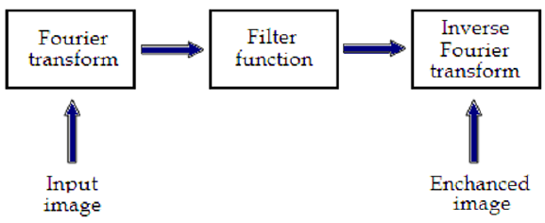**Basics steps of frequency domain filtering. The filtering in the spatial domain demands a filter mask (it is also referred as kernel or convolution filter). The filter mask is a matrix of odd usually size which is applied directly on the original data of the image. The mask is centred on each pixel of the initial image. For each position of the mask the pixel values of the image is multiplied by the corresponding values of the mask. The products of these multiplications are then added and the value of the central pixel of the original image is replaced by the sum. This must be repeated for every pixel in the image. The procedure is described schematically in Fig. 4. If the filter, by which the new pixel value was calculated, is a linear function of the entire pixel values in the filter mask (e.g. the sum of products), then the filter is called linear. If the output pixel is not a linear weighted combination of the input pixel of the image then the filtered is called non-linear. According to the range of frequencies they allow to pass through filters can be classified as low pass or high pass. Low pass filters allow the low frequencies to be retained unaltered and block the high frequencies. Low pass filtering removes noise and smooth the image but at the same time blur the image as it does not preserve the edges. High pass filters sharpness the edges of the image (areas in an image where the signal changes rapidly) and enhance object edge information. A severe disadvantage of high pass filtering is the amplification of statistical noise present in the measured counts. The next section is referred to three of the most common filters used by MatLab: the mean, median and Gaussian filter.**

**7. Discuss the various image sharpening filters present in frequency domain. 10**

8. Discuss the various image smoothing filters present in frequency domain. 10

**Frequency Domain Filters** are used for smoothing and sharpening of image by removal of high or low frequency components. Sometimes it is possible of removal of very high and very low frequency. Frequency domain filters are different from spatial domain filters as it basically focuses on the frequency of the images. It is basically done for two basic operation i.e., Smoothing and Sharpening.

These are of 3 types:

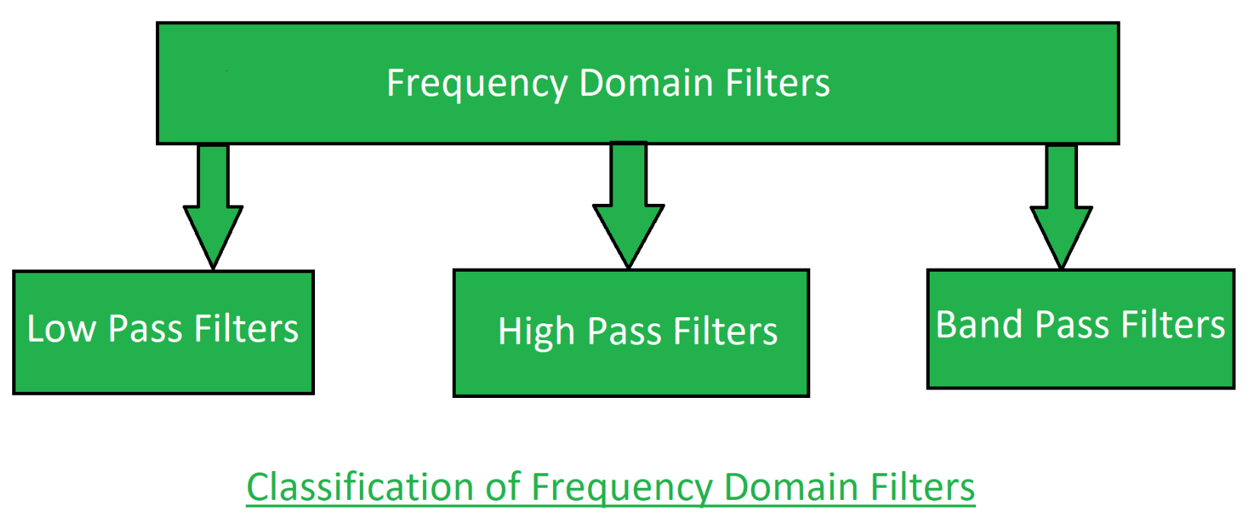

**1. Low pass filter:**  
Low pass filter removes the high frequency components that means it keeps low frequency components. It is used for smoothing the image. It is used to smoothen the image by attenuating high frequency components and preserving low frequency components.  
Mechanism of low pass filtering in frequency domain is given by:

G(u, v) = H(u, v) . F(u, v)

where F(u, v) is the Fourier Transform of original image

and H(u, v) is the Fourier Transform of filtering mask

**2. High pass filter:**  
High pass filter removes the low frequency components that means it keeps high frequency components. It is used for sharpening the image. It is used to sharpen the image by attenuating low frequency components and preserving high frequency components.  
Mechanism of high pass filtering in frequency domain is given by:

H(u, v) = 1 - H'(u, v)

where H(u, v) is the Fourier Transform of high pass filtering

and H'(u, v) is the Fourier Transform of low pass filtering

**3. Band pass filter:**  
Band pass filter removes the very low frequency and very high frequency components that means it keeps the moderate range band of frequencies. Band pass filtering is used to enhance edges while reducing the noise at the same time.

**9. Explain the usage of Homomorphic filtering in frequency domain. 10**

### Homomorphic filtering:

The illumination-reflectance model can be used to develop a frequency domain procedure for improving the appearance of an image by simultaneous gray-level range compression and contrast enhancement. An image f(x, y) can be expressed as the product of illumination and reflectance components:

https://benchpartner.com/bp-content/uploads/2021/10/29-TN8nYvNhfjk.jpg

Equation above cannot be used directly to operate separately on the frequency components of illumination and reflectance because the Fourier transform of the product of two functions is not separable

10. Explain image degradation /restoration model with diagram. 6

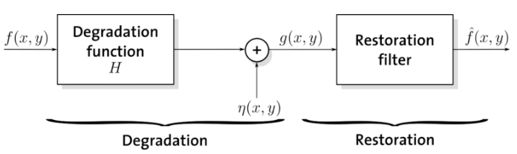



**11. Discuss the various noise probability density functions found in image**

**processing applications.10**

**1. Gaussian Noise:**

Gaussian Noise is a statistical noise having a probability density function equal to normal distribution, also known as Gaussian Distribution. Random Gaussian function is added to Image function to generate this noise. It is also called as electronic noise because it arises in amplifiers or detectors. Source: thermal vibration of atoms and discrete nature of radiation of warm objects.

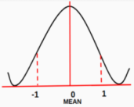

Fig.4 Plot of Probability Distribution Function

The side image is a bell-shaped probability distribution function which have mean 0 and standard deviation(sigma) 1.

**2. Impulse Noise:**

Impulse Function: In the discrete world impulse function on a vale of 1 at a single location and In continuous world impulse function is an idealised function having unit area.

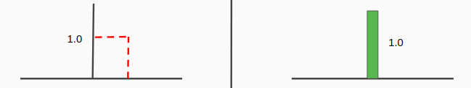

Fig.6 Impulse function in discrete world and continuous world

**2.1 Types of Impulse Noise:**

There are three types of impulse noises. Salt Noise, Pepper Noise, Salt and Pepper Noise.

**Salt Noise:**Salt noise is added to an image by addition of random bright (with 255 pixel value) all over the image.

**Pepper Noise:**Salt noise is added to an image by addition of random dark (with 0 pixel value) all over the image.

**Salt and Pepper Noise:**Salt and Pepper noise is added to an image by addition of both random bright (with 255 pixel value) and random dark (with 0 pixel value) all over the image.This model is also known as data drop noise because statistically it drop the original data values [5]. Source: Malfunctioning of camera’s sensor cell.

## 3. Poisson Noise:

The appearance of this noise is seen due to the statistical nature of electromagnetic waves such as x-rays, visible lights and gamma rays. The x-ray and gamma ray sources emitted number of photons per unit time. These rays are injected in patient’s body from its source, in medical x rays and gamma rays imaging systems. These sources are having random fluctuation of photons. Result gathered image has spatial and temporal randomness. This noise is also called as quantum (photon) noise or shot noise.

## 4. Speckle Noise

A fundamental problem in optical and digital holography is the presence of speckle noise in the image reconstruction process. Speckle is a granular noise that inherently exists in an image and degrades its quality. Speckle noise can be generated by multiplying random pixel values with different pixels of an image.

**12. Briefly discuss the noise reduction capabilities of the following spatial**

**filters:**

**a. Arithmetic mean filter**

**b. Geometric mean filter**

**c. Harmonic mean filter**

**d. Contraharmonic mean filter** 20

# Arithmetic Mean Filter

## Command

Image  
 Filters  
 Arithmetic Mean Filter

## Description

Applies a arithmetic mean filter to an image.

An arithmetic mean filter operation on an image removes short tailed noise such as uniform and Gaussian type noise from the image at the cost of blurring the image. The arithmetic mean filter is defined as the average of all pixels within a local region of an image.

The arithmetic mean is defined as:

Arithmetic mean

Pixels that are included in the averaging operation are specified by a mask. The larger the filtering mask becomes the more predominant the blurring becomes and less high spatial frequency detail that remains in the image.

## Dialog box

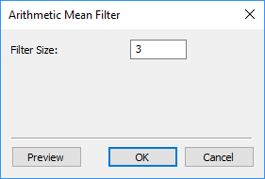

**Filter Size**: size of the filter mask; a larger filter yields stronger effect.

Click Preview to judge the results.

Click OK to proceed.

# Geometric Mean Filter

## Command

Image  
https://www.digimizer.com/manual/help/png/mint.gif Filters  
https://www.digimizer.com/manual/help/png/mint2.gif Geometric Mean Filter

## Description

Applies a geometric mean filter to an image.

In the geometric mean method, the color value of each pixel is replaced with the geometric mean of color values of the pixels in a surrounding region. A larger region (filter size) yields a stronger filter effect with the drawback of some blurring.

The geometric mean is defined as:

Geometric mean

The geometric mean filter is better at removing Gaussian type noise and preserving edge features than the arithmetic mean filter. The geometric mean filter is very susceptible to negative outliers.

## Dialog box

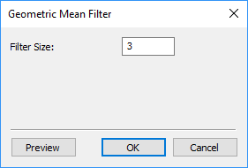

**Filter Size**: larger filter yields stronger effect.

Click Preview to judge the results.

Click OK to proceed.

# Harmonic Mean Filter

## Command

Image  
https://www.digimizer.com/manual/help/png/mint.gif Filters  
https://www.digimizer.com/manual/help/png/mint2.gif Harmonic Mean Filter

## Description

Applies a harmonic mean filter to an image.

In the harmonic mean method, the color value of each pixel is replaced with the harmonic mean of color values of the pixels in a surrounding region.

The harmonic mean is defined as:

Harmonic mean

A larger region (filter size) yields a stronger filter effect with the drawback of some blurring.

The harmonic mean filter is better at removing Gaussian type noise and preserving edge features than the arithmetic mean filter. The harmonic mean filter is very good at removing positive outliers.

## Dialog box

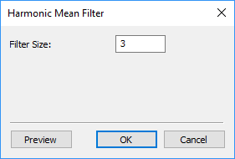

**Filter Size**: larger filter yields stronger effect.

Click Preview to judge the results.

Click OK to proceed.

# Contraharmonic Mean Filter

## Command

Image  
https://www.digimizer.com/manual/help/png/mint.gif Filters  
https://www.digimizer.com/manual/help/png/mint2.gif Contraharmonic Mean Filter

## Description

Applies a contraharmonic mean filter to an image.

With a contraharmonic mean filter, the color value of each pixel is replaced with the contraharmonic mean of color values of the pixels in a surrounding region.

The contraharmonic mean with order Q is defined as:

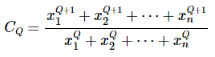

A contraharmonic mean filter reduces or virtually eliminates the effects of salt-and-pepper noise. For positive values of Q, the filter eliminates pepper noise. For negative values of Q it eliminates salt noise. It cannot do both simultaneously.

Note that the contraharmonic filter is simply the arithmetic mean filter if Q = 0, and the harmonic mean filter if Q = −1.

A larger region (filter size) yields a stronger filter effect with the drawback of some blurring.

## Dialog box

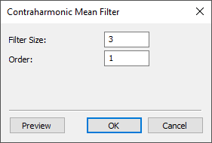

**Filter Size**: larger filter yields stronger effect.

**Order**: the order Q of the filter.

Click Preview to judge the results.

Click OK to proceed.